SQL VARIABLES

🔹 Purpose
# Source: AI Source: Provided by: [Data Path: Persons Table -> ID Column: 1, Name_En Column: Motasem Essam] -> From: [ChatGPT] on [6/11/2026]
MySQL system variables determine how the server behaves.
These commands allow you to:
- Check the current configuration settings (SHOW VARIABLES)
Useful for database diagnostics, performance tuning, and understanding system behavior.

what is variables in MySQL
# Source: AI Source: Provided by: [Data Path: Persons Table -> ID Column: 1, Name_En Column: Motasem Essam] -> From: [ChatGPT] on [6/11/2026]
In MySQL, a variable is a configuration setting or value that controls the behavior of the server or your session. These variables can affect performance, connection settings, storage behavior, SQL mode, etc.

🔍 Types of Variables in MySQL

1. System Variables
# Source: AI Source: Provided by: [Data Path: Persons Table -> ID Column: 1, Name_En Column: Motasem Essam] -> From: [ChatGPT] on [6/11/2026]
These are predefined by MySQL and can be:

Scope | Description
Global | Affects the entire MySQL server and all sessions.
Session | Affects only the current user connection (your session).

✅ Example:
# Source: AI Source: Provided by: [Data Path: Persons Table -> ID Column: 1, Name_En Column: Motasem Essam] -> From: [ChatGPT] on [6/11/2026]
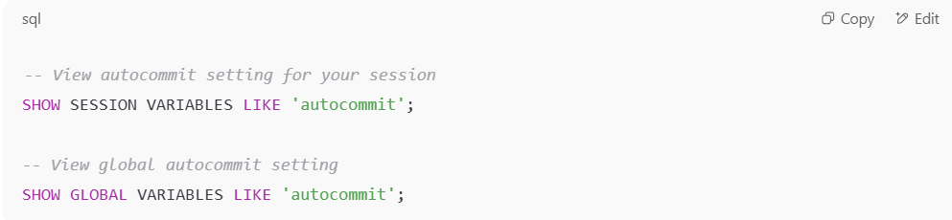
-- View autocommit setting for your session
SHOW SESSION VARIABLES LIKE 'autocommit';

-- View global autocommit setting
SHOW GLOBAL VARIABLES LIKE 'autocommit';

🧠 Examples of Important Variables
# Source: AI Source: Provided by: [Data Path: Persons Table -> ID Column: 1, Name_En Column: Motasem Essam] -> From: [ChatGPT] on [6/11/2026]
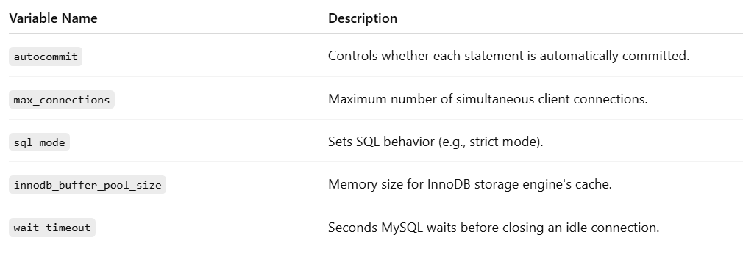
Variable Name | Description
autocommit | Controls whether each statement is automatically committed.
max_connections | Maximum number of simultaneous client connections.
sql_mode | Sets SQL behavior (e.g., strict mode).
innodb_buffer_pool_size | Memory size for InnoDB storage engine's cache.
wait_timeout | Seconds MySQL waits before closing an idle connection.

2. User-Defined Variables
# Source: AI Source: Provided by: [Data Path: Persons Table -> ID Column: 1, Name_En Column: Motasem Essam] -> From: [ChatGPT] on [6/11/2026]
You can define your own variables in a session using @.

✅ Example:
# Source: AI Source: Provided by: [Data Path: Persons Table -> ID Column: 1, Name_En Column: Motasem Essam] -> From: [ChatGPT] on [6/11/2026]
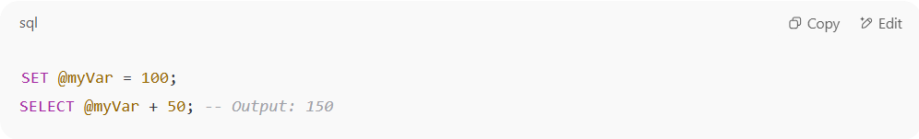
SET @myVar = 100;
SELECT @myVar + 50; -- Output: 150

🔧 Modify System Variables
# Source: AI Source: Provided by: [Data Path: Persons Table -> ID Column: 1, Name_En Column: Motasem Essam] -> From: [ChatGPT] on [6/11/2026]
- Global scope (requires SUPER/ADMIN privilege):
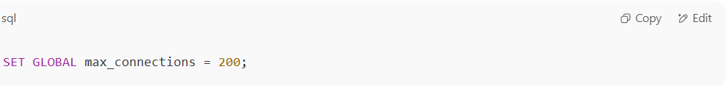SET GLOBAL max_connections = 200;

- Session scope (for your session only):
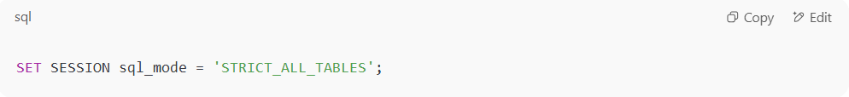
SET SESSION sql_mode = 'STRICT_ALL_TABLES';

Let me know if you'd like a practice quiz or hands-on lab on MySQL variables!

SHOW VARIABLES
# Source: AI Source: Provided by: [Data Path: Persons Table -> ID Column: 1, Name_En Column: Motasem Essam] -> From: [ChatGPT] on [6/11/2026]
✅ Syntax:
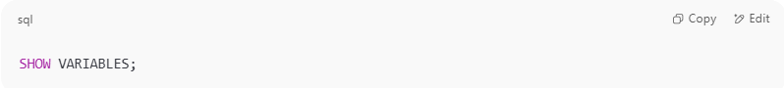
SHOW VARIABLES;

✅ Filter specific variable:
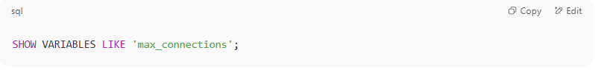
SHOW VARIABLES LIKE 'max_connections';

🔍 Example Output:
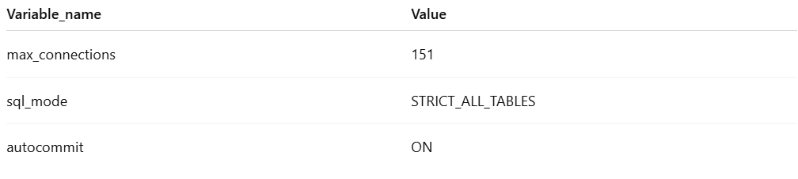
Variable_name | Value
max_connections | 151
sql_mode | STRICT_ALL_TABLES
autocommit | ON

🧠 Common Use Cases
# Source: AI Source: Provided by: [Data Path: Persons Table -> ID Column: 1, Name_En Column: Motasem Essam] -> From: [ChatGPT] on [6/11/2026]
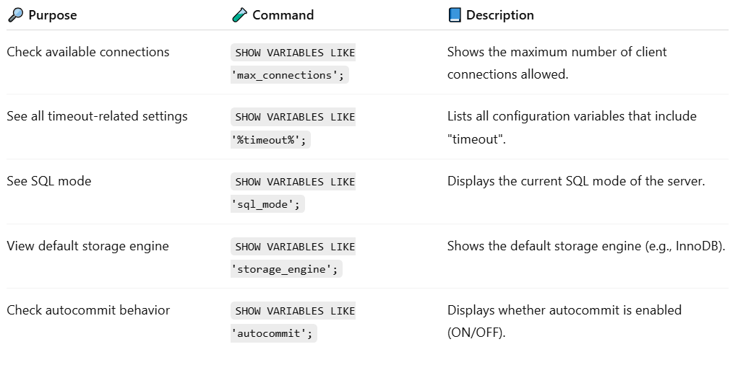

🔎 Purpose | 🧪 Command | 📘 Description
Check available connections | SHOW VARIABLES LIKE 'max_connections'; | Shows the maximum number of client connections allowed.
See all timeout-related settings | SHOW VARIABLES LIKE '%timeout%'; | Lists all configuration variables that include "timeout".
See SQL mode | SHOW VARIABLES LIKE 'sql_mode'; | Displays the current SQL mode of the server.
View default storage engine | SHOW VARIABLES LIKE 'storage_engine'; | Shows the default storage engine (e.g., InnoDB).
Check autocommit behavior | SHOW VARIABLES LIKE 'autocommit'; | Displays whether autocommit is enabled (ON/OFF).

🧪 Bonus: Compare Global vs. Session Variables
# Source: AI Source: Provided by: [Data Path: Persons Table -> ID Column: 1, Name_En Column: Motasem Essam] -> From: [ChatGPT] on [6/11/2026]
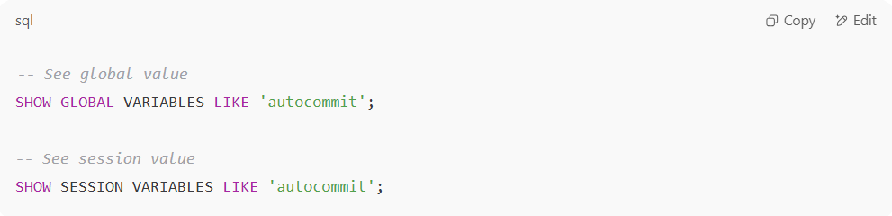
-- See global value
SHOW GLOBAL VARIABLES LIKE 'autocommit';

-- See session value
SHOW SESSION VARIABLES LIKE 'autocommit';

🧰 Tip:
# Source: AI Source: Provided by: [Data Path: Persons Table -> ID Column: 1, Name_En Column: Motasem Essam] -> From: [ChatGPT] on [6/11/2026]
To set a variable (like turning off autocommit):
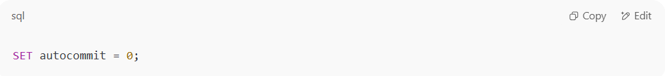
SET autocommit = 0;

✅ Summary
# Source: AI Source: Provided by: [Data Path: Persons Table -> ID Column: 1, Name_En Column: Motasem Essam] -> From: [ChatGPT] on [6/11/2026]
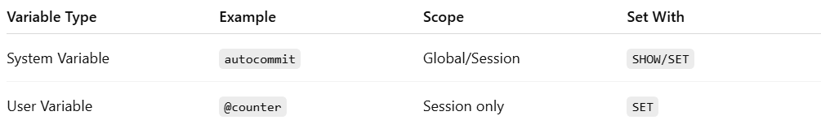
Variable Type | Example | Scope | Set With
System Variable | autocommit | Global/Session | SHOW/SET
User Variable | @counter | Session only | SET

Example

basic command
# Source: ScreenShot Source: Provided by: [Persons Table -> ID Column: 1, Name_En Column: Motasem Essam] -> Tool: [Automation Table -> ID Column: 16, Name_En Column: Screen Capture] -> From [Operating System: Wampserver64 -> phpmyadmin] on [6/11/2026]
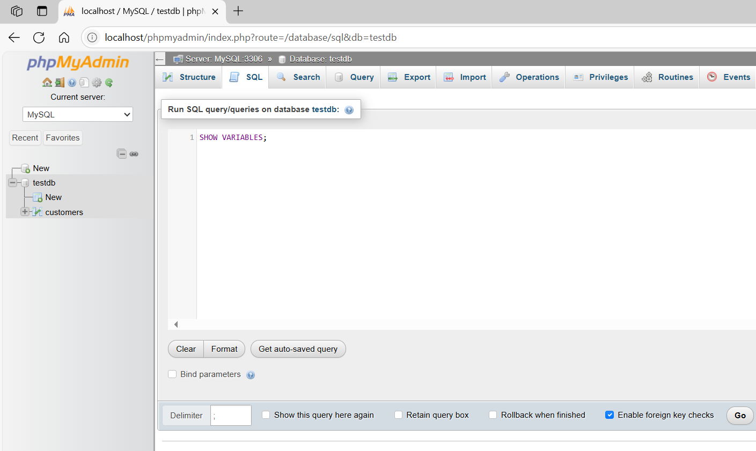
SHOW VARIABLES;
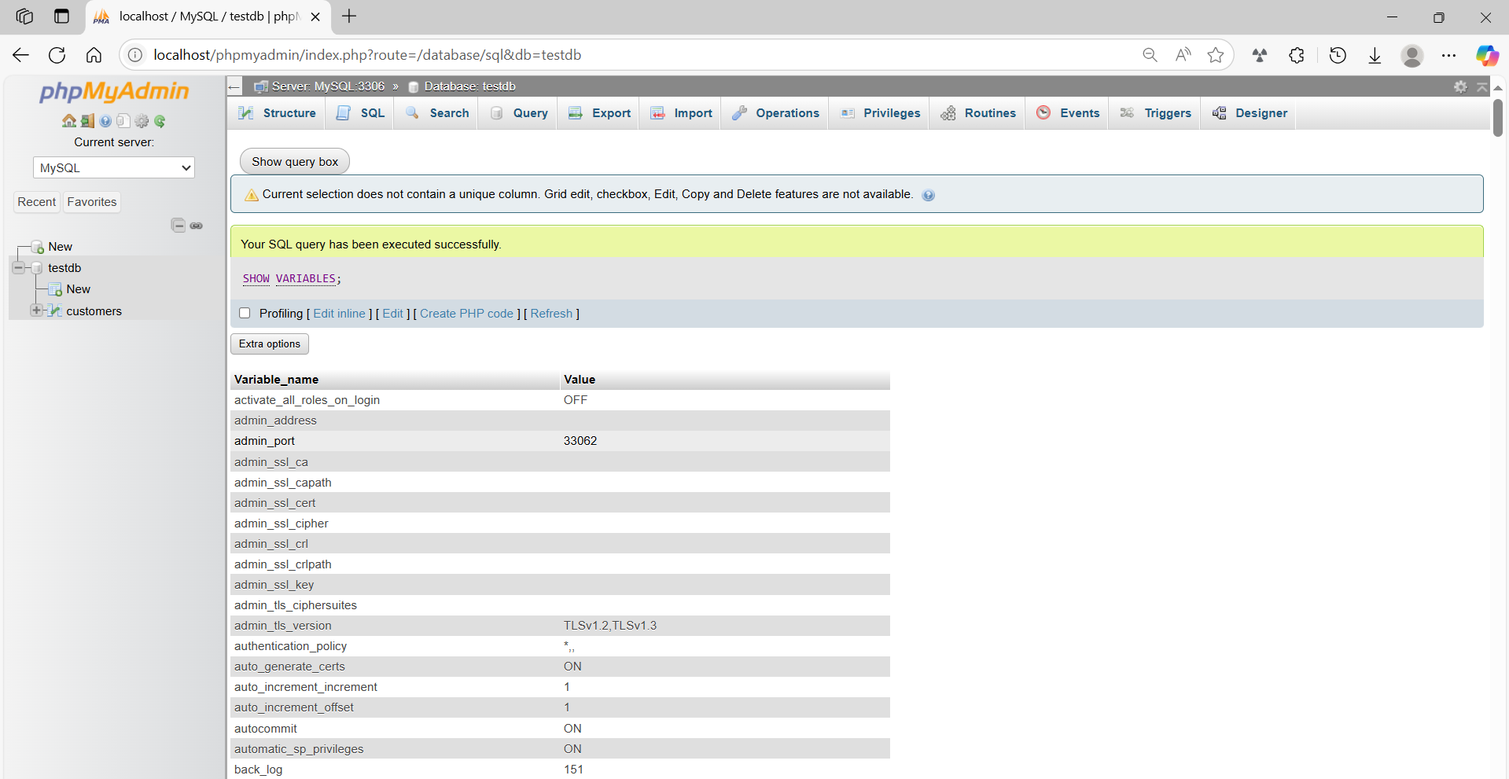

basic command
# Source: ScreenShot Source: Provided by: [Persons Table -> ID Column: 1, Name_En Column: Motasem Essam] -> Tool: [Automation Table -> ID Column: 16, Name_En Column: Screen Capture] -> From [Operating System: Wampserver64 -> phpmyadmin] on [6/11/2026]
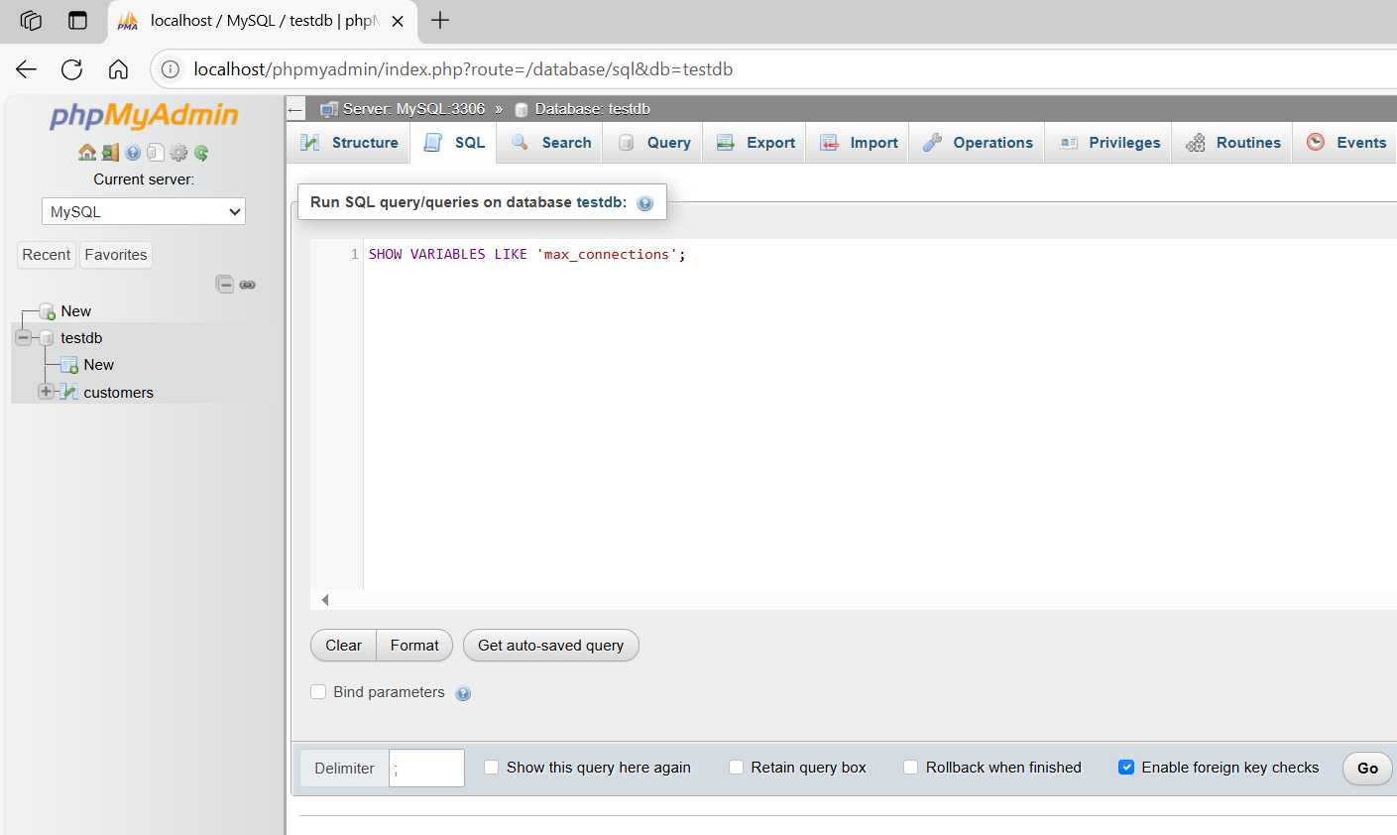
SHOW VARIABLES LIKE 'max_connections';
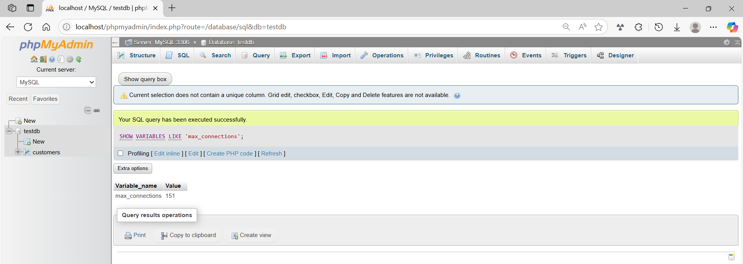

basic command
# Source: ScreenShot Source: Provided by: [Persons Table -> ID Column: 1, Name_En Column: Motasem Essam] -> Tool: [Automation Table -> ID Column: 16, Name_En Column: Screen Capture] -> From [Operating System: Wampserver64 -> phpmyadmin] on [6/11/2026]
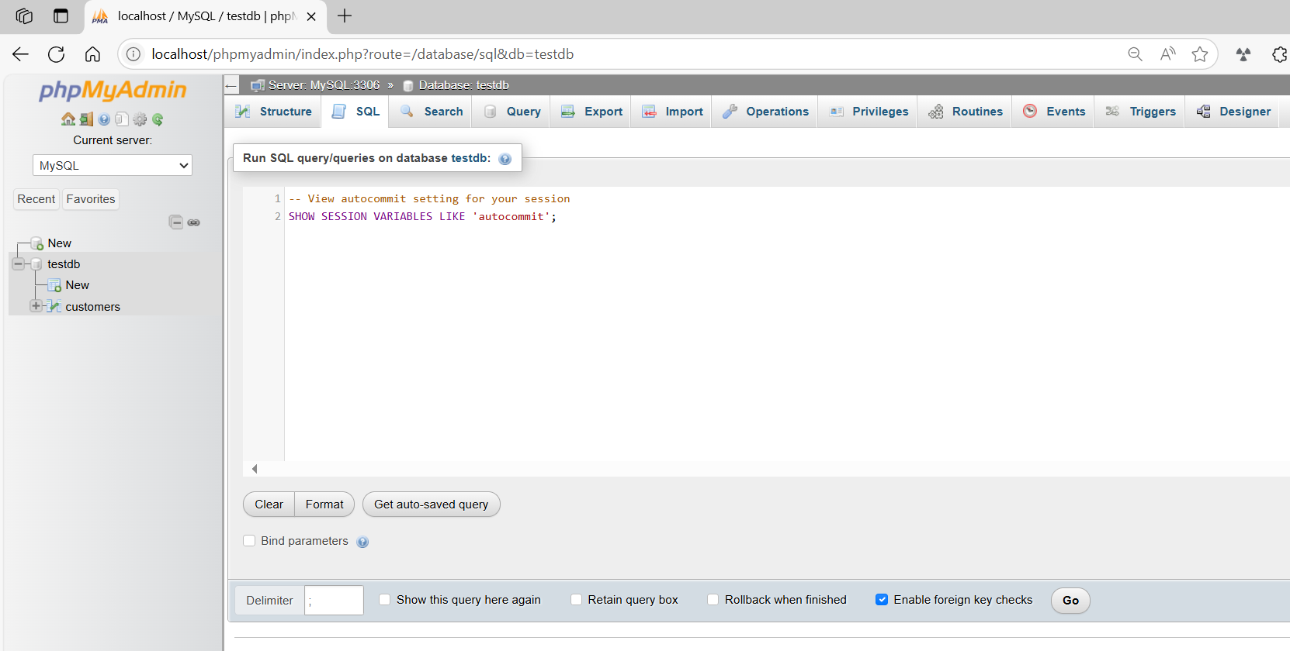
-- View autocommit setting for your session
SHOW SESSION VARIABLES LIKE 'autocommit';
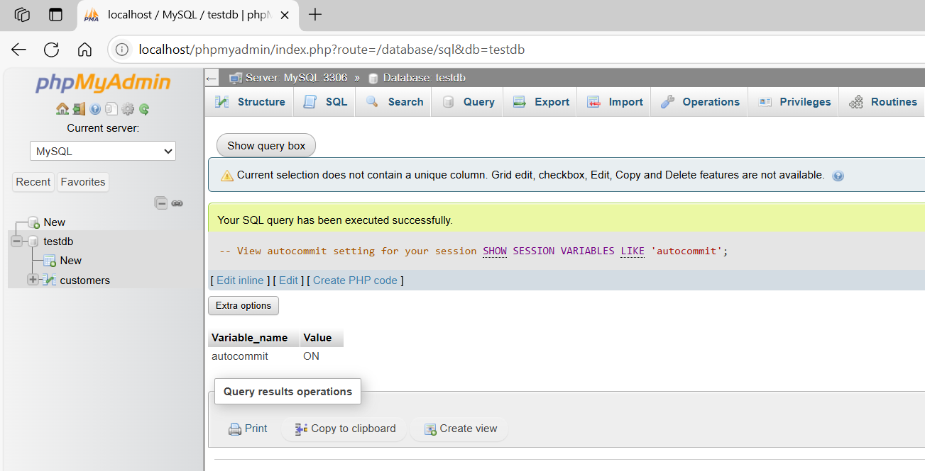

basic command
# Source: ScreenShot Source: Provided by: [Persons Table -> ID Column: 1, Name_En Column: Motasem Essam] -> Tool: [Automation Table -> ID Column: 16, Name_En Column: Screen Capture] -> From [Operating System: Wampserver64 -> phpmyadmin] on [6/11/2026]
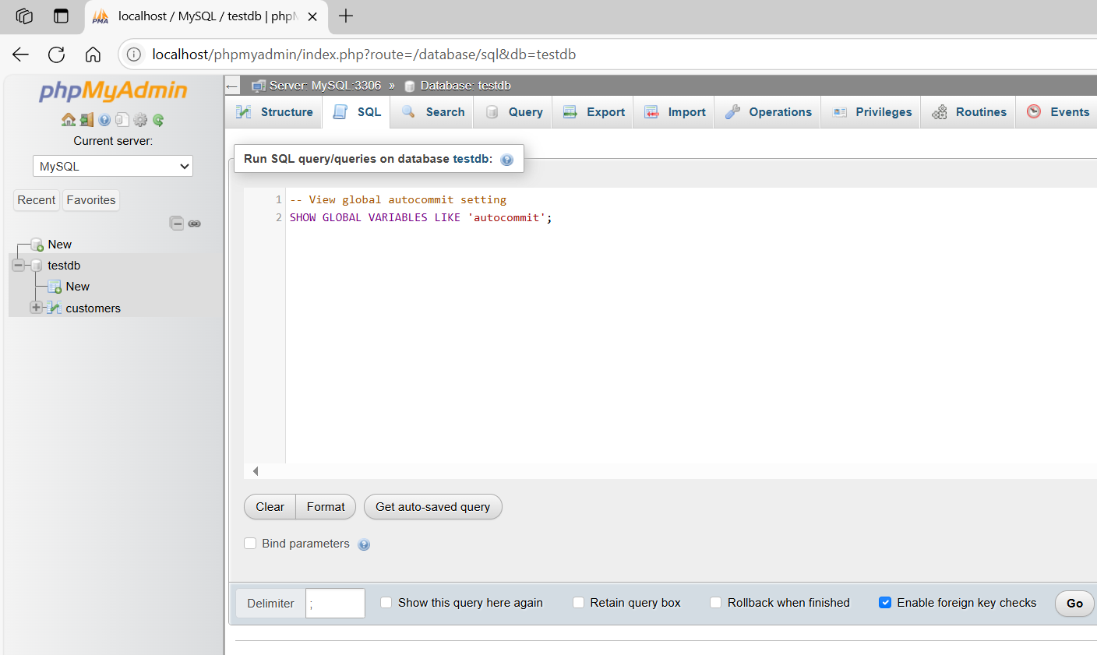
-- View global autocommit setting
SHOW GLOBAL VARIABLES LIKE 'autocommit';
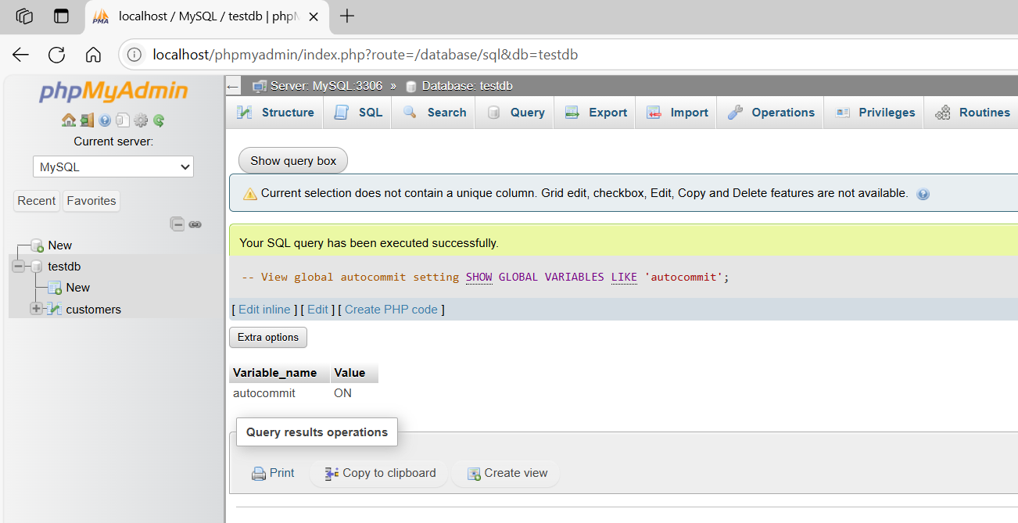

basic command
# Source: ScreenShot Source: Provided by: [Persons Table -> ID Column: 1, Name_En Column: Motasem Essam] -> Tool: [Automation Table -> ID Column: 16, Name_En Column: Screen Capture] -> From [Operating System: Wampserver64 -> phpmyadmin] on [6/11/2026]
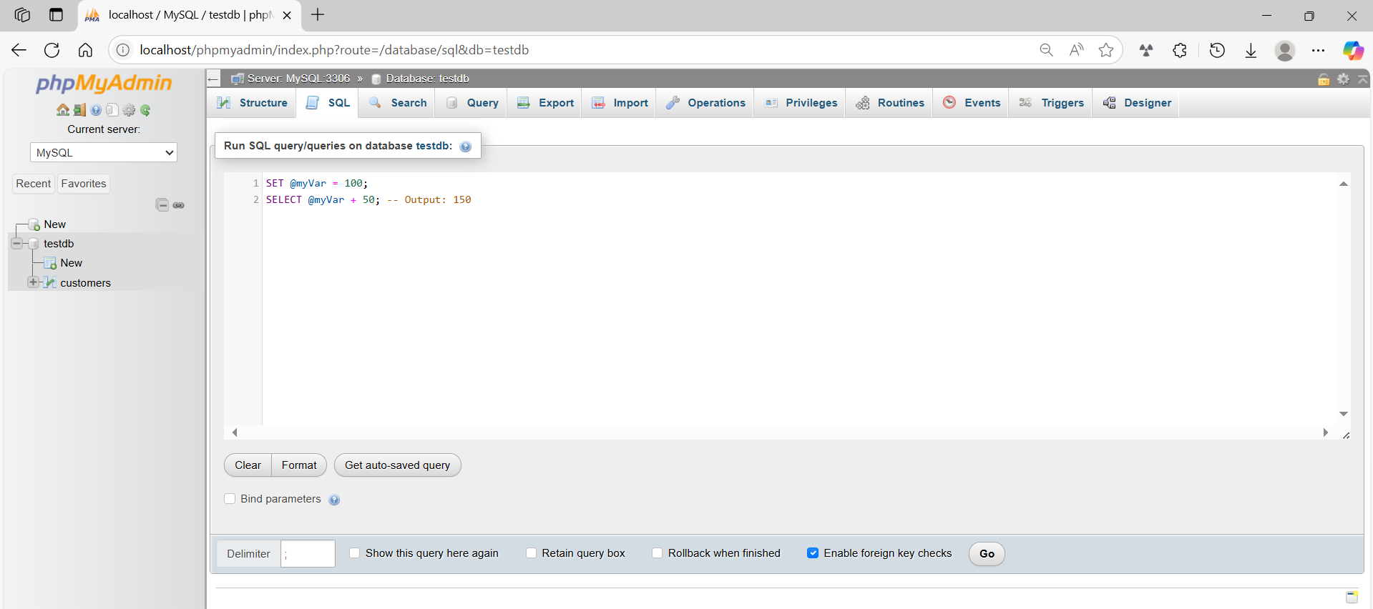
SET @myVar = 100;
SELECT @myVar + 50; -- Output: 150
